**EFFECTS OF NANOPARTICLES BIOSYNTHESIZED *Azardirachta indica* ON TERMITES (*Nasutitermes kemneri* Dudley)**

**Abstract**

Termites (*Nasutitermes kemneri* Dudley) constitute major threats to agricultural crop, products and wooden infrastructures. Synthetic insecticides have been used against termites but they constitute environmental hazard and their availability is a major concern. Therefore, nano-insecticides were formulated using neem plant parts (leaf, bark and seed) and their mixtures with silver nitrates against termites. This experiment was carried out at the Insectarium of Crop and Environmental Protection Department, Ladoke Akintola University of Technology, Ogbomoso. Synthetic insecticides (Dichlorvos) and control were included in the treatment for comparisons. Each of the treatment was applied through contact and fumigant. The treatments were arranged in Complete Randomized Design and each treatment was replicated three times. Data were collected on percentage mortality after different hours of exposure, 30, 1, 2, 3, 6, and 24 and means were separated using Tukey's honestly significant difference (HSD) Test. Among all the tested nano-insecticides, nano neem seed, neem bark, and all other mixtures of the nano-insecticides had the same significant effect on termites with 83-97% mortality after 24 hours when applied through fumigant and 40-47% when applied through contact but mixture of neem leaf and bark had a lower mortality, 20% (contact). However, nano neem leaf had 70% and 63% mortality when applied through contact and fumigant respectively. Application of nano-insecticides through fumigant killed higher significant number of termites (79.6%) when compared with the application through contact (46.3%), The Kaplan-Meier survival analysis reveals that nano-insecticides effectively control termites through fumigant. Therefore, nano-insecticides from neem plant parts can be incorporated into pest management programme of termites.

**Introduction**

Termites are terrestrial polymorphic eusocial insects originated from a common ancestor with the sub-social cryptocercid roaches, in the late Jurassic of Mesozoic Era (Engel *et al*., 2009). Termites have highly organized colonies and are characterized by overlapping generations. They are eurytopic and distributed throughout the temperate, tropical and subtropical regions of the world, with the highest diversity found in tropical forests (Pervez, 2018).

Termites have been around for millions of years and are well adapted to the environmental stresses and thereby making their control a very tedious management practice. Being underground, they are fairly well protected from common hazards and the possibility of direct termiticide application (Sindhu *et al.,* 2011). Wood and moisture are two primary requisites for successful establishment of most termite infestations.

However, termites constitute major menace to agricultural production in the tropics. They can cause denudation of farmlands, destroy growing crops, farm structures as well as the harvest in the store (Loko *et al*., 2015; Ogedegbe and Ogwu, 2015). Termites have been pests for as long as humans have used wood to build shelters, structures, and furniture, and some are almost exclusively found in human-made objects (Su, 2019). Some species can cause the death of healthy trees (Rao *et al*., 2012).

Termite control by chemicals involves their application to the wood or to the soil (Sindhu *et al.,* 2011), the use of proper application method of termiticides is important to reduce their negative impact to the environment (Khan and Ahmad, 2018). In recent years, researchers have focused on developing natural products that are effective against termites without any negative impacts on human health and the environment. One such promising approach is the use of botanical insecticides from natural resources especially plants, among this is the neem tree, *A. indica*,a tropical evergreen tree in the Meliaceae family which can be found across Southeast Asia and West Africa, with a few trees lately planted in the Caribbean and Central America, including México (Roshan and Verma, 2015).

Neem is now well recognized as a natural product with insecticidal properties (Amin *et al.*,2019; Islam *et al.*, 2009). Products generated from neem trees are used as effective insect growth regulators (IGRs) and can also help manage nematodes and fungi (Lokanadhan *et al*., 2012).

The effectiveness of botanical pesticides to manage agriculturally economic pests is vital due to their renewable tendency, significant environmental safety and human welfare. Plant-based pesticides are predominantly used in low-income and emerging nations to control pests because of their cost-effectiveness, availability, accessibility and easy-to-use (Ngegba *et al*., 2022). Therefore, this research study is to determine the bio-efficacy of nanoparticles synthesized pesticide of neem tree in the control of termites. The specific objectives are: to determine the insecticidal properties of silver nitrate nanoparticles synthesized insecticides of neem plant parts (leaf, bark and seed) on termites and also to determine the best mode of action of silver nitrate nanoparticles synthesized insecticides of neem plant parts (leaf, bark and seed) on termites.

**Materials and Methods**

**Study Environment**

The experiment was carried out at the Crop and Environmental Protection Insectarium on Ladoke Akintola University of Technology, Teaching and Research Farm, Ogbomoso, Oyo State. The temperature of the insectarium ranges from 260C - 280C. Ogbomosho is located on the 8°101 North of the equator and 4°101 East of the Greenwich meridian. It is a derived Savannah region and its 104 km North East of Ibadan, 58 km North West of Osogbo, 57 km South West of Ilorin and 53 km North East of Oyo. The climate condition of Ogbomoso could be described as hot humid tropical falls in Southern Guinea Savanna of Nigeria with a mean temperature of 270C and annual rainfall of 1400 mm (Olaniran *et al.*,2016). Average temperature of the insect room was 27.50C while carrying out the experimental research work.

Adult termites were collected at the Apiary section of Ladoke Akintola University of Technology Teaching and Research Farm by digging the mould and picking up some active workers with the mould in the colony. The muold which contained active termites were placed in the plastic insect box. The insect box was covered with black film nylon to prevent the light rays and transferred to the insectarium.

**Insects rearing**

A large rectangular plastic insect box of 310.5 m3 (length 45cm, breadth 30cm, height 23cm) covered with black film nylon was used to house the studied insects. This insect box was provided with water and dead organic material like soft woods and it was taking to the insectarium and left for two weeks before the experimental work started to ensure that the insects adapt to their new habitat.The insects were studied for their adaptation to the insectarium conditions before the bioassay started so as to ensure active living insects were used during the experimental trials.

**Plant Materials Collection and Processing**

Neem plants parts namely, leaves, bark and seeds were harvested from LAUTECH, Teaching and Research Farm, the plant parts were air dried in the Crop and Environmental Protection Laboratory for 21 days. The plant materials were subjected to grinding into powdery form separately using a Silver-crest electric grinding machine (7000 Watts). The powdery form of each plant part was taken to Microbiology Department, LAUTECH for nano-insecticides formulation according to Lateef *et al.* (2015).

The electric grinder (Silvercrest Heavy Duty Commercial Grinder Blender 7000watts) was used for grinding the plant materials into powder as indicated. Also, an electric sensitive scale (Camry) was used to obtain precise measurement of some materials during the research study.

## Experimental Design and Entomological Bioassays

The experiment was carried out in the insectarium using a Complete Randomized Design, nine treatments were used during the experiment including the synthetic insecticides and control. The synthetic insecticides solution was prepared by dissolving 1 ml dichlorvos in 2 litres of distilled water. The large plastic insect box covered with black nylon was used to house the insects and bioassays were carried out by picking the adult termites into transparent small plastic containers containing fine sand particles and labelled for each treatment respectively.

The small plastic container has the volume of 0.78 m3 (height 4.5cm, radius 5.5cm) and was employed in carrying out our bioassays, it provides is transparent and allows easy observation and data collection during the experiments. Fine particles of sand were sieved and used as a substrate for the insects, we used fine sand particles. This provided a suitable environment for the organisms, allowing them to exhibit natural behaviors and interactions.

Transparent insect box (size) used for the contact toxicity experiment was lined with 40 g of fine sand particles (particles size) to make the container to be natural for the studied insect. The plastic container used weighed 8 g. Later, ten (10) active termites were carefully picked and introduced into each designated plastic insect box. Medical syringe was used to measure 10 ml of each insecticide’s solution separately and the termites in the container were sprayed accordingly.

Fumigant toxicity was carried out using transparent insect box lined with 40 g of fine sand particles (particles size) to make the container to be natural for the studied insect. The plastic container used weighed 8 g. Later, ten (10) active termites were carefully picked and introduced into each designated plastic insect box. 1g of cotton wool was measured using Camry sensitive weighing scale and impregnated with 10ml of each insecticide’s solution separately after which it was introduced into the designated insect box accordingly.

## 

## Data collection and analysis

The number of dead termites was recorded at six different time intervals: 30 minutes, 1 hour, 2 hours, 3 hours, 6 hours, and 24 hours. The mortality percentage was calculated using the formula:

$\% Mortality= \frac{Number of dead termites}{Total number of termites}×100$

This formula was applied to each time interval to determine the percentage of termites that died over time. All data were recorded in percentage (%) format to minimize errors and ensure consistency across replicates.

All statistical analyses were conducted using R version 4.4.2 (2024-10-31) -- "Pile of Leaves" (R Core Team, 2024). The following R packages were used for specific analyses: base R, agricolae, tidyverse, and survminer packages

The mortality data were subjected to a one-way analysis of variance (ANOVA) to determine if there were statistically significant differences in termite mortality across the different time intervals. The ANOVA was conducted at a 5% significance level (α = 0.05). For the Tukey's Honestly Significant Difference (HSD) test, *agricolae* package was used to compute the post-hoc result to compare the mean mortality percentages between the time intervals and identify which specific intervals differed significantly in accordance with De Mendiburu Delgado, 2009 & Field et al., 2012.

We performed survival analysis to inform the most effective mode of application using the Kaplan-Meier method by estimating the survival probability of termites over time. This method was used to construct survival curves, which visually represent the proportion of termites surviving at each time interval (Kaplan & Meier, 1958). The Kaplan-Meier curves were compared across different treatment groups (if applicable) to assess the impact of different modes of application on termite survival. Log-rank tests were used to determine if there were significant differences in survival probabilities between groups (Peto & Peto, 1972).

## Results

## Effect of insecticides through contact mode on termites

*Table 1: Effect of insecticides through contact mode on termites*

|  |  |  |  |  |  |  |
| --- | --- | --- | --- | --- | --- | --- |
|  | Hours of Exposure | | | | | |
| Treatments | 30 | 1 | 2 | 3 | 6 | 24 |
| Dichlorvos | 80.00a | 100.00a | 100.00a | 100.00a | 100.00a | 100.00a |
| Control | 0.00b | 3.33b | 3.33bc | 3.33bc | 13.33bc | 13.33c |
| Neem Seed | 0.00b | 0.00b | 0.00c | 0.00c | 0.00c | 46.67bc |
| Neem Leaf | 3.33b | 6.67b | 10.00b | 13.33b | 16.67b | 70.00ab |
| Neem Bark | 3.33b | 3.33b | 3.33bc | 3.33bc | 10.00bc | 43.33bc |
| Neem Leaf + Bark | 0.00b | 0.00b | 0.00c | 0.00c | 3.33bc | 40.00bc |
| Neem Leaf + Seed | 0.00b | 0.00b | 0.00c | 3.33bc | 6.67bc | 20.00c |
| Neem Seed + Bark | 0.00b | 3.33b | 3.33bc | 3.33bc | 3.33bc | 43.33bc |
| Neem Leaf + Bark + Seed | 0.00b | 0.00b | 6.67bc | 10.00bc | 16.67b | 40.00bc |

Means with same superscript(s) along the column are not significantly different at 5% level of probability.

*Figure 1: Mortality Trends Over Time for Contact Application Across Treatments*

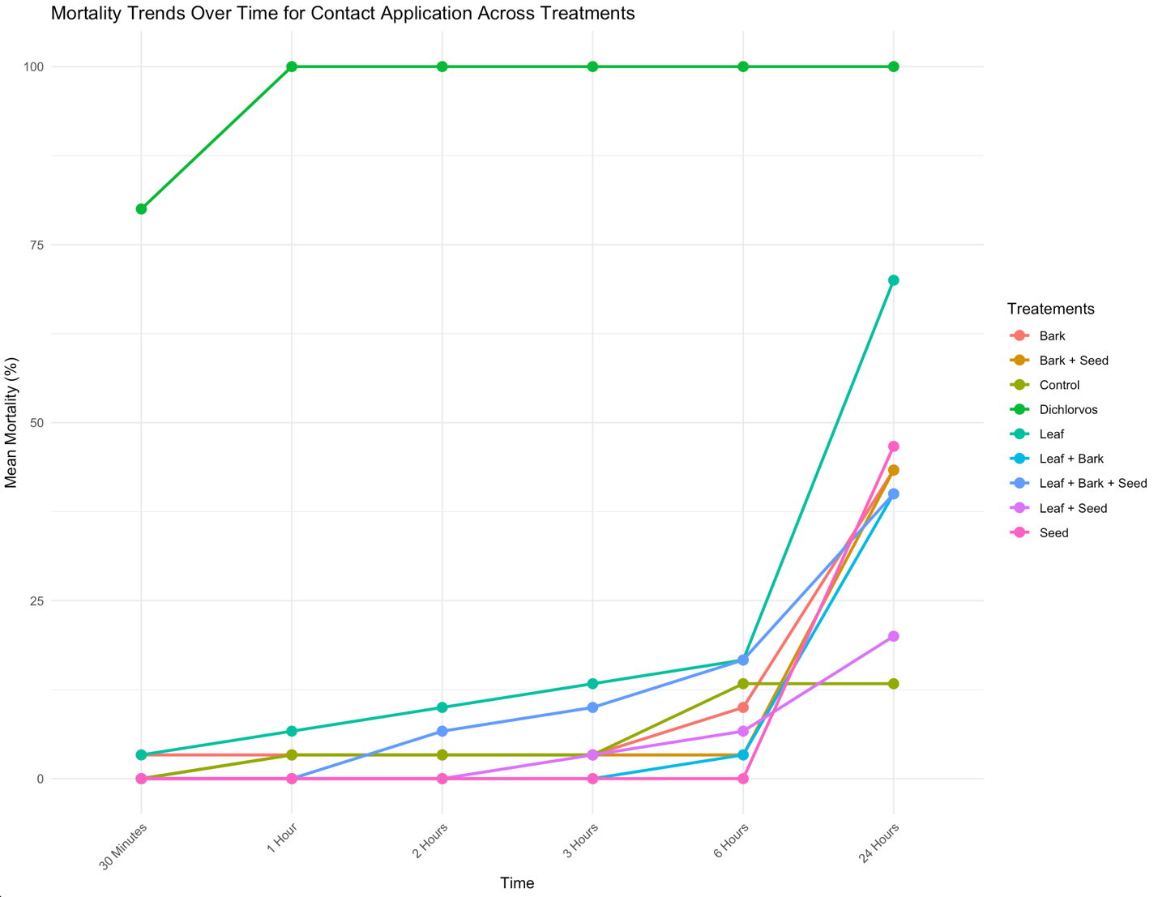

Table 1 displays the effect of insecticides through contact on the studied insect while figure 2 shows the trend of mortality over time. As displayed in the figure 1, at 30 minutes after the exposure, all the nano-insecticides had the same significant effect on the treated insect however, 80% mortality was recorded on termites treated with dichlorvos. After 1 hour of application, all the termites treated with dichlorvos were killed. Meanwhile, the tested nano-insecticides did not exhibit significant effects on the termites when compare with the untreated termites.

At 2 hours, 10% of the termites treated with neem leaf were dead, meanwhile neem bark and neem seed + bark had the same significant effect on the treated termites, similar result was observed on termites treated with the combination of the plant extracts (Neem leaf + bark + seed).

No mortality was recorded from the plastic container treated with Neem seed and Neem leaf + bark. However, 13.3% of the termite were killed by the nano neem leaf, while 10% were killed by the combination of the plant extracts. The same significant effect was observed from the termites treated with neem bark, neem leaf + seed, neem seed + bark, after 3 hours of exposure.

After 6 hours of exposure, no mortality was recorded on the termites treated with nano neem seed, meanwhile, Nano neem bark exhibited the same significant effect with the combination of the three plant extracts (neem leaf + bark + seed).

None of the tested nano-insecticides significantly performed as dichlorvos to contact. Meanwhile, 70% mortality was recorded from the termites treated with nano neem leaf after 24 hours of exposure. Application of nano neem seed compete effectively with the combination of all the tested nano-insecticides, meanwhile, nano neem leaf + seed had the least number of termite mortality, (20%) after 24 hours of exposure.

## Effect of insecticides through fumigant mode on termites

*Table 2: Effect of insecticides through fumigant mode on termites*

|  |  |  |  |  |  |  |
| --- | --- | --- | --- | --- | --- | --- |
|  | Hours of Exposure | | | | | |
| Treatments | 30 | 1 | 2 | 3 | 6 | 24 |
| Dichlorvos | 56.67a | 93.33a | 100.00a | 100.00a | 100.00a | 100.00a |
| Control | 0.00b | 3.33b | 20.00b | 23.33c | 33.33c | 36.67c |
| Neem Seed | 0.00b | 6.67b | 16.67b | 30.00c | 63.33abc | 96.67ab |
| Neem Leaf | 0.00b | 10.00b | 23.33b | 33.33c | 53.33abc | 63.33bc |
| Neem Bark | 20.00b | 23.33b | 26.67b | 43.33bc | 50.00bc | 70.00abc |
| Neem Leaf + Bark | 13.33b | 20.00b | 50.00b | 76.67ab | 83.00ab | 96.67ab |
| Neem Leaf + Seed | 3.33b | 16.67b | 26.67b | 33.33c | 46.67bc | 83.33ab |
| Neem Seed + Bark | 6.67b | 16.67b | 33.33b | 53.33bc | 56.67abc | 83.33ab |
| Neem Leaf + Bark + Seed | 3.33b | 13.33b | 26.67b | 43.33bc | 70.00abc | 86.67ab |

Means with same superscript(s) along the column are not significantly different at 5% level of probability.

*Figure 2: Mortality Trends Over Time for Fumigant Application Across Treatments*

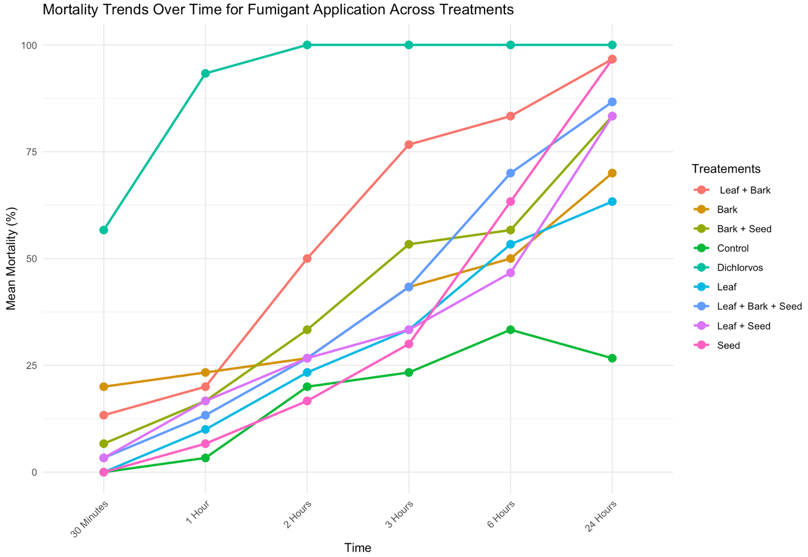

The data displays the effects of insecticides through fumigant on the studied insect. At 30 minutes after exposure, all the nano-insecticides had the same significant effect on the treated insect, conversely, 56.7% was recorded on termites treated with dichlorvos. At 1 hour of exposure, 93% mortality was recorded on the treated insects. Meanwhile, the tested nano-insecticides did not exhibit significant effect on the studied insect when it is compared with the untreated insects.

At 2 hours, all the termites treated with dichlorvos were killed. It was recorded that 50% of the termites treated with the combination of neem leaf and bark were killed. Similar mortality results were observed on termites treated with neem bark, combination of neem leaf and bark, and combination of all the plant extracts.

Least mortality was recorded on the untreated container of insect. However, comparable significant effect was recorded on termites treated with combination of nano neem leaf and bark (76.7%), while increase effects were recorded also recorded on all other treatments.

After 6 hours of exposure, highest mortality was recorded in the container treated with nano neem leaf + bark. Also, all other treatments recorded comparable effects on termites.

None of the tested nano-insecticides performed well significantly when compared with dichlorvos through fumigant. Meanwhile, 96% mortality was recorded from the termites with the nano neem seed and nano neem bark + seed. Similar mortality was recorded on nano neem leaf + seed and nano neem seed + bark (83.3%) although the combination of all the plant extracts performed better than both treatments (86.7%).

## Comparison of modes of application of insecticides on termites

*Figure 3: Comparison of modes of application of insecticides on termites*

Means with same superscript(s) are not significantly different at 5% level of probability.

Figure 1 shows comparison between the two modes of application used in this study on termites. Fumigant mode of application recorded high significant effects of insecticides used on the studied insect compare to contact mode of application throughout the various hours of exposure.

## Comparison of the effects of the modes of application of insecticides on termites

Table 4: Comparison of the effects of the modes of application of insecticides on termites

|  |  |  |  |  |  |  |  |
| --- | --- | --- | --- | --- | --- | --- | --- |
|  |  | Hours of Exposure | | | | | |
| Treatments | Mode of application | 30 | 1 | 2 | 3 | 6 | 24 |
| Dichlorvos | Contact | 80.00a | 100.00a | 100.00a | 100.00a | 100.00a | 100.00a |
| Fumigant | 56.67a | 93.33a | 100.00a | 100.00a | 100.00a | 100.00a |
| Control | Contact | 0.00b | 3.33b | 3.33d | 3.33fg | 13.33fg | 13.33e |
| Fumigant | 0.00b | 3.33b | 20.00cd | 23.33defg | 33.33defg | 36.67ed |
| Neem Seed | Contact | 0.00b | 0.00b | 0.00d | 0.00g | 0.00g | 46.67bcde |
| Fumigant | 0.00b | 6.67b | 16.67cd | 30.00cdef | 63.33bcd | 96.67a |
| Neem Leaf | Contact | 3.33b | 6.67b | 10.00cd | 13.33efg | 16.67efg | 70.00abcd |
| Fumigant | 0.00b | 10.00b | 23.33cd | 33.33cde | 53.33bcd | 63.33abcd |
| Neem Bark | Contact | 3.33b | 3.33b | 3.33b | 3.33fg | 10.00g | 43.33cde |
| Fumigant | 20.00b | 23.33b | 26.67bcd | 43.33cd | 50.00bcde | 70.00abcd |
| Neem Leaf + Bark | Contact | 0.00b | 0.00b | 0.00d | 0.00g | 3.33g | 40.00de |
| Fumigant | 13.33b | 20.00b | 50.00b | 76.67ab | 83.33ab | 96.67a |
| Neem Leaf + Seed | Contact | 0.00b | 0.00b | 0.00d | 3.33fg | 16.67g | 20.00e |
| Fumigant | 3.33b | 16.67b | 26.67bcd | 33.33cde | 46.67cdef | 83.33abc |
| Neem Seed + Bark | Contact | 0.00b | 3.33b | 3.33d | 3.33fg | 3.33g | 43.33cde |
| Fumigant | 6.67b | 16.67b | 33.33bc | 53.33bc | 56.67bcd | 83.33abc |
| Neem Leaf + Bark + Seed | Contact | 0.00b | 0.00b | 6.67cd | 10.00cfg | 16.67efg | 40.00de |
| Fumigant | 3.33b | 13.33b | 26.67bcd | 43.33cd | 70.00ab | 86.67ab |

Means with same superscript(s)along the column are not significantly different at 5% level of probability.

Table 4 shows the comparison of effect of the mode of application of insecticide on the studies insect. After 30 minutes of exposure, the two modes of application at the same significant effect on termite, meanwhile, dichlorvos performed better the nano-insecticides when applied through contact mode of application.

After one hour of exposure, 100% mortality was recorded on termites treated with dichlorvos when applied through contact. All the nano-insecticides tested on termites exhibit no significant effects when compared with untreated termite when compared with untreated termites through the two modes of application.

There was 100% mortality recorded from termites treated with dichlorvos through fumigant mode of application, half of the tested population of termite was killed by the combination of nano neem leaf plus bark through fumigant at 2 hours of exposure. neem bark, combination of neem leaf and seed and combination of all the plant extracts had the same effect on the termites (26.67%) through fumigant mode of application after 2 hours of exposure.

Application of the mixture of neem leaf and bark through fumigant killed 76.7% of the studied insects but when applied through contact, no mortality was recorded after 3 hours of exposure. Fumigant mode of application exhibit the same significant effects on termites treated with nano neem bark and combination of all the plant extracts. Mortality of 30.0% of the termites were killed by neem seed through fumigant, meanwhile, there was no mortality recorded when it was applied through contact. Equally the same significant effects were shown by neem bark and nano neem and combination of neem seed and bark when applied through contact (3.3%). Also, application of neem leaf and mixture of neem leaf and seed had the same significant effect through fumigant (33.3%). The nano-insecticides had significant mortality rate on termites through fumigant compared with untreated termites.

Nano neem leaf combined with bark when applied through fumigant had high mortality rate than all other nano-insecticides (83.3%), meanwhile, there was 70% mortality on the treated insects through fumigant by combination of all the plant extracts. The result shows that nano neem seed on the treated insects with fumigant killing 63.3% and no mortality was recorded when applied through contact. All the nano-insecticides performed well when applied through fumigant mode of application.

After 24 hours of exposure, insects treated with nano neem seed and combination of neem leaf and bark had the same interactive effects when compared with dichlorvos when applied through fumigant. Same significant effects were observed through fumigant from the insect treated with the combination of neem leaf and seed, and neem seed and bark (83.3%), meanwhile, application of the combination of neem seed and bark, and neem bark had the same significant effects through contact (43.3%). This was also observed on the termites treated with mixture of neem leaf and bark and combination of all the plant extracts (40.0%). Meanwhile, the application of neem leaf and seed when applied through contact had the least significant effects (20.0%) when compared with untreated insects (13.3%). Application of neem bark through fumigant had the same efficacy as application of neem leaf through contact.

*Figure 4: Survival cuve: Contact vs. Fumigant Treatments*

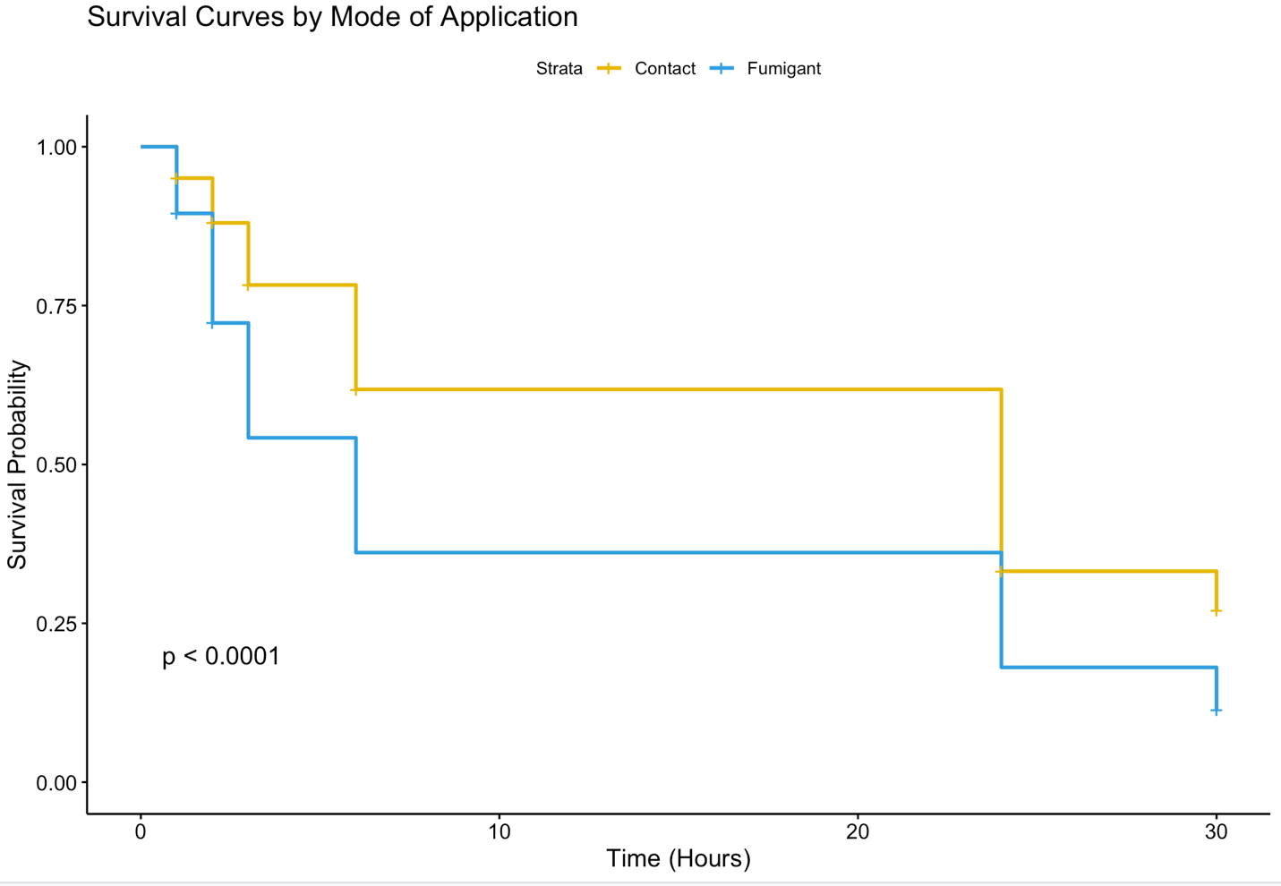

Figure 4 present the Kaplan-Meier curve and illustrates the differential impact of the two insecticide application methods (Contact and Fumigant) on the studied insect. The results show that the Fumigant treatment led to a significantly faster decline in survival probability compared to the Contact method, as indicated by the sharp drops in the blue curve. The statistical significance (p < 0.0001) further confirms that the mode of application plays a crucial role in the insecticidal effect.

Within the first few hours of exposure, a noticeable mortality rate was observed among insects exposed to fumigant treatment, suggesting that the gaseous phase of the insecticide rapidly affects the target organisms. In contrast, insects subjected to contact treatment exhibited a slower decline in survival, indicating a more prolonged but still effective mode of action.

After approximately 10 hours, the survival probability of insects exposed to the fumigant method dropped below 50%, while the contact method maintained a relatively higher survival rate. However, by the end of the 24-hour exposure period, both methods had resulted in substantial mortality, though the fumigant-treated group reached this point more rapidly.

## Discussion

Synthetic insecticides have played a pivotal role in pest control for several decades (Grdiša and Gršić, 2013). They are specifically designed to target and eliminate unwanted insects, ranging from agricultural pests to disease-carrying vectors (Shoeb and Nahar, 2023). By disrupting the physiological processes of pests, synthetic insecticides have been effective in mitigating crop damage, preventing the spread of diseases, and protecting human health in various scenario (Thoms and Busacca, 2015; Navarro and Navarro, 2020). There is a great awareness on the implications of the continuous use of synthetic insecticides as a result of environmental hazards and risks (Özkara *et al.*,2016), therefore, there is need to find alternatives to the use of synthetic insecticides especially in developing countries. This study demonstrated the efficacy of nano-biosynthesized silver nitrate *A. indica* on termites.

The result shows that the tested nano-insecticides effectively killed termites after 24 hours of exposure when compared with the untreated studied insects, this indicate that the nano bioinsecticides can be used to control termites. This observation concurs with the previous studies by Achio *et* *al*., (2012), who reported insecticidal effects of various neem preparations (powder, aqueous extract and oil emulsifiable concentrate) on termites. Also, Santos *et al.*,(2017) reported the efficacy of essential oil of *Lippia sidoides* on termites which was applied through contact and fumigant. In addition, Adeyemo *et al.*,(2015) also asserted the biocidal effects of *Datura stramonium* and *Thevetia neriifolia* on termites.

This current study is however not a pioneer work as the use of neem plants for nano-insecticides formulations of neem plants has been used in managing various insect pests, such as *Agrotis ipsilon* larvae, whitefly (*Bemisia tabaci* G.), and adult storage insect pests (*Sitophilus oryzae and Tribolium castaneum*) (Amin *et al.*,2019; Iqbal *et al.*, 2022; Choupanian *et al.*,2017).

There was variation in mortality of the studied insect to various nano-insecticides when nano-insecticides formulations were applied through different modes of application. Nano neem leaf had higher significant mortality than all other nano-insecticides tested through contact on termites and this is in-line Allam *et al.* (2022); with silver nano-synthesized insecticides of Chili pepper, Turmeric, Garlic, and Black pepper used against termites. Islam *et al.*  (2009) also proved that nano neem leaf repelled termites’ infestation in dried wood. Mortality of treated termites was higher with nano neem applied through fumigant throughout the experimental trials, this can be attributed to the presence of Azadiractin which is higher than that of other neem parts (Lokanadhan *et al.*,2012; Isman, 1997; Pandreka *et al.*,2015; Sundaram,1996). Also, combination of neem leaf and bark had same significant effect on termites like neem seed when compared to other tested nano-insecticides, there would have been a synergetic effect between the mixture which agrees with the result of Cynthia *et al.* (2016) who concluded that a mixture of extracts used was more effective (bio-potent) in the toxicity and repellency test of individual and mixture plant extracts on termites. Also, this aligns with the study of Alao *et al.* (2011); Alao and Adebayo (2015) combinations of different active ingredients can enhance the insecticidal activity of botanicals insecticides.

Based on the modes of application, the tested nano-insecticides killed faster when applied through fumigant than contact, this observation is in-line with the earlier report by Boyer *et al.* (2012) that use of fumigants is one of the most economical and convenient tools for managing insect pests. Also, report by Park and Shin, (2005) also supported that fumigant mode of application of botanical insecticides killed Japanese termites than other mode of application.

None of the applied nano-insecticides was effective as dichlorvos, however, dichlorvos killed through the two modes of application which agrees with the report by Adeyemi and Adedire, (2022) Asogwa et al. (2009); Rust and Saran, (2006); Rust and Su, (2012); Xie *et al.,* (2013) that synthetic insecticides are highly effective against termites.

The nano-insecticides used displayed contact and fumigant modes of application in a dose-time dependent effects on the termites, late response was observed when compared with dichlorvos and literature has been submitted to prove the delayed effects on insect pests (Alao and Adebayo*,* 2015), in addition to that, the prolonged effects if the nano formulated due to slow release as well as protection of the active ingredients which has been reported by Bhattacharya *et al.* (2020); this may be related to the contact application of nano neem leaf insecticide which also displays mortality above 50% after 24 hours of exposure.

## Conclusion

Based on this research work, none of the nano-insecticides killed the studied insect at earlier stage of application. Also, formulations of nano-insecticides from neem plant parts (leaf, bark and seed) exhibited insecticidal control of termites. However, modes of application influenced the effectiveness of the nano-insecticides, with fumigant application showing faster results compared to contact application. Although none of the applied nano-insecticides were as effective as dichlorvos, a synthetic insecticide, the delayed response and prolonged effects observed with the nano formulations suggest their potential for long-term termite control.

The findings of this study demonstrated the possibility of nano-biosynthesized insecticides as an effective substitute for synthetic pesticides in the management of termites. The development of efficient, environmentally responsible, and financially viable methods for pest management in both agricultural and residential contexts can be facilitated by further research and development in this area.

Further research work should be established on the use of nanoparticles synthesized neem plant parts against other insect pests. Also, further research work should be done on different levels of concentration against termites. This current study compared contact and fumigant modes of application as the appropriate methods meanwhile, fumigant application is a preferred choice.

**References**

Achio, S., Ameko, E., Kutsanedzie, F. and Alhassan, S. (2012). Insecticidal effects of various neem preparations against some insects of agricultural and public health concern. *International Journal of Research in BioSciences*, *1*(2), 11-19.

Adeyemi, J. A. and Adedire, C. O. (2022). Effects of aqueous extracts of six plant materials and four synthetic insecticides on the mortality of subterranean termites, Macrotermes subhyalinus (Isoptera: Termitidae) in the laboratory. *International Journal of Tropical Insect Science*, *42*(2), 1429-1435.

Adeyemo, A. C., Ogungbite, O. C. and Agbola, O. P. (2015). Biocidal efficacy of two medicinal plant oil extracts used as termicides against subterranean termites Macrotermes subhyalinus L. *Zoology and Ecology*, *25*(3), 257-261.

Alao, F. O. and Adebayo, T. A. (2015). Comparative efficacy of Tephrosia vogelii and Moringa oleifera against insect pests of watermelon (*Citrullus lanatus* Thumb). *Int. Lett. Nat. Sci*, *35*, 71-78.

Alao, F. O., Adebayo, T. A., Olaniran, O. A. and Akanbi, W. B. (2011). Preliminary evaluation of the insecticidal potential of organic compost extracts against insect pests of Okra (Abelmoschus esculentus (L.) Moench). *Asian Journal of Plant Science and Research*, 1(3), 123-130.

Allam, R. O. H., Badawy, A. M. M. and Ali, M. A. (2022). Green synthesized silver nanoparticles for controlling subterranean termites, *Psammotermes hypostoma* (Desn.). *SVU-International Journal of Agricultural Sciences*, *4*(1), 135-143.

Amin, A. R. H., Bayoumi, A. E. D., Dimetry, N. Z. and Youssef, D. A. (2019). Efficiency of Nano-formulations of neem and peppermint oils on the bionomics and enzymatic activities of *Agrotis ipsilon* larvae (Lepidoptera: Noctuidae). *J. Nat. Resour. Ecol*. Manag, 4, 102-111.

Asogwa, E.U., Okelana, F.A., Ndubuaku, T.C.N. and Mokwunye, I.U. (2009). The termicidal effects of Chlorpyrifos 48 EC, Endosulfan 35 EC, Dichlorvos 1000 EC and Diazinon 600 EC against termites in South-West Nigeria. *Afr. J. Biotechnol*. 8 (1), 048–052.

Bhattacharya, A., Epidi, T. T. and Kannan, M. (2020). Nano-technology applications in pest management. Innovative Pest Management Approaches for the 21st Century: Harnessing Automated Unmanned Technologies, 391-401.

Boyer, S., Zhang, H., Lempérière, G., 2012. A review of control methods and resistance mechanisms in stored-product insects. *Bull. Entomol. Res*. 102 (2), 213–229.

Choupanian, M., Omar, D., Basri, M. and Asib, N. (2017). Preparation and characterization of neem oil nanoemulsion formulations against Sitophilus oryzae and Tribolium castaneum adults. *Journal of pesticide science*, 42(4), 158-165.

Cynthia, O. C., Precious, O. and Lynda, O. S. (2016). The toxicity and repellency of some plant extracts applied as individual and mixed extracts against termites (*Macrotermes bellicosus*). *J Entomol Zool Stud*, *4*, 406-418.

De Mendiburu Delgado, F. (2009). A statistical analysis tool for agricultural research.

Engel, M. S., Grimaldi, D. A. and Krishna, K. (2009). Termites (Isoptera): Their phylogeny, classification, and rise to ecological dominance. *American Museum Novitates, 3650*, 1–27.

Grdiša, M. and Gršić, K. (2013). Botanical insecticides in plant protection. *Agriculturae Conspectus Scientificus*, *78*(2), 85-93.

Iqbal, N., Hazra, D. K., Purkait, A., Agrawal, A. and Kumar, J. (2022). Bioengineering of neem nano-formulation with adjuvant for better adhesion over applied surface to give long term insect control. Colloids and Surfaces B: Biointerfaces, 209, 112176.

Islam, M. M., Shams, M. I., Ilias, G. N. M. and Hannan, M. O. (2009). Protective antifungal effect of neem (*Azadirachta indica*) extracts on mango (*Mangifera indica*) and rain tree (*Albizia saman*) wood*. International Biodeterioration & Biodegradation*, 63(2), 241-243.

Isman, M. B. (1997). Neem and other botanical insecticides: barriers to commercialization. Phytoparasitica, 25, 339-344.

Khan, M. A. and Ahmad, W. (2018). *Termites and sustainable management*. Cham, Switzerland: Springer.

Lateef, A., Azeez, M.A., Asafa, T.B., Yekeen, T.A., A. A. A, Oladipo, I.C., Azeez, L., Ajibade, S.E., Ojo, S.A., Gueguim-Kana, E.B. and Beukes, L.S. (2015). Biogenic Synthesis of Silver Nanoparticles Using Pod Extract of *Cola Nitida*: Antibacterial, Antioxidant Activities and Application as Additive in Paint. *Journal of Taibah University for Science*, 10(2016), 551-562. <http://dx.doi.org/10.1016/j.jtusci.2015.10.010>

Lokanadhan, S., Muthukrishnan, P. and Jeyaraman, S. (2012). Neem products and their agricultural applications. *Journal of Biopesticides*, *5*, 72.

Loko, Y. L., Agre, P., Orobiyi, A., Dossou-Aminon, I., Roisin, Y., Tamo, M. and Dansi, A. (2016). Farmers' knowledge and perceptions of termites as pests of yam (Dioscorea spp.) in Central Benin. *International Journal of Pest Management*, *62*(1), 75-84.

Malyutina A, Tang J, Pessia A (2023). “drda: An R Package for Dose-Response Data Analysis Using Logistic Functions.” Journal of Statistical Software, 106(4), 1–26. doi:10.18637/jss.v106.i04.

Navarro, S. and Navarro, H. (2020) Advances in insect pest management in postharvest storage of cereals: Use of controlled atmosphere and temperature control. In Advances in Postharvest Management of Cereals and Grains; Maier, D.E., Ed.; Burleigh Dodds Science Publishing Limited: Cambridge, UK p. 478.

Ngegba, P. M., Cui, G., Khalid, M. Z., & Zhong, G. (2022). Use of botanical pesticides in agriculture as an alternative to synthetic pesticides. *Agriculture*, 12(5), 600.

Ogedegbe, A. B. O. and Ogwu, B. C. (2015). Termite Infestation on Farmlands at Ugoniyekorhionmwon Community, Edo State, Nigeria: A Farmers' Perception. *International Journal of Pure and Applied Sciences and Technology*, *28*(1).

Olaniran, O. A., Alao, F. O., Yusuf, S. Y. and Adebayo, T. A. (2016). Effects of Selected Plant Extracts Formulation on Insect Pests and Nutritional Quality of Egg Plant Fruits (Solanum melogena L.). *International Journal of Applied Agricultural and Apicultural Research*, *12*(2), 59-70.

Özkara, A., Akyıl, D. and Konuk, M. (2016). Pesticides, environmental pollution and health. In Environmental health risk-hazardous factors to living species. *IntechOpen.*

Pandreka, A., Dandekar, D. S., Haldar, S., Uttara, V., Vijayshree, S. G., Mulani, F. A., Aarthy, T. and Thulasiram, H. V. (2015). Triterpenoid profiling and functional characterization of the initial genes involved in isoprenoid biosynthesis in neem (*Azadirachta indica*). *BMC Plant Biology*, *15*, 1-14.

Park, I. K. and Shin, S. C. (2005). Fumigant activity of plant essential oils and components from garlic (Allium sativum) and clove bud (Eugenia caryophyllata) oils against the Japanese termite (Reticulitermes speratus Kolbe). *Journal of agricultural and food chemistry*, *53*(11), 4388-4392.

Pervez, A. (2018). Termite biology and social behaviour. Termites and Sustainable Management: Biology, Social Behaviour and Economic Importance, 1, 119-143.

Rao, A. N., Samatha, C. and Sammaiah, C. (2012). Bio-diversity of termites in Bhadrachalam forest region, Khammam District, Andhra Pradesh. *Journal of Biodiversity*, *3*(1), 55-59.

Roshan, A. and Verma, N. K. (2015). A brief study on neem (*Azarrdirachta indica* A.) and its application–A review. *Research Journal of Phytomedicine*, *1*(1), 01-03.

Rust, M. K. and Saran, R. K. (2006). Toxicity, repellency, and transfer of chlorfenapyr against western subterranean termites (Isoptera: Rhinotermitidae). *Journal of Economic Entomology*, *99*(3), 864-872

Rust, M. K. and Su, N. Y. (2012). Managing social insects of urban importance. *Annual review of entomology*, *57*, 355-375.

Santos, A. A., de Oliveira, B. M. S., Melo, C. R., Lima, A. P. S., Santana, E. D. R., Blank, A. F., Picanço, M.C., Araújo, A.A., Cristaldo, P.F. and Bacci, L. (2017). SSub-lethal effects of essential oil of *Lippia sidoides* on drywood termite *Cryptotermes brevis* (Blattodea: Termitoidea). *Ecotoxicology and Environmental Safety*, 145, 436-441.

Shoeb, M. and Nahar, N. (2023). Pesticides: Impact on Environmental and Sustainable Management. In *Transcending Humanitarian Engineering Strategies for Sustainable Futures* (pp. 120-141). IGI Global.

Sindhu, S. S., Rakshiya, Y. S. and Verma, M. K. (2011). Biological control of termites by antagonistic soil microorganisms. *Bioaugmentation, Biostimulation and Biocontrol*, 261-309.

Su, N. Y. (2019). Development of baits for population management of subterranean termites. *Annual Review of Entomology*, *64*, 115-130.

Sundaram, K. M. (1996). Azadirachtin biopesticide: a review of studies conducted on its analytical chemistry, environmental behaviour and biological effects. *Journal of Environmental Science and Health Part B*, *31*(4), 913-948.

Thoms, E.M. and Busacca, J.D. (2015). Fumigants. In Encyclopedia of Food and Health; Caballero,B., Finglas, P.M., Toldrá, F., Eds.; Academic Press: Cambridge, MA, USA, pp. 150–156.

Xie, Y., Du, Q., Huang, Q. and Lei, C. (2013). Evaluation of formic acid toxicity to subterranean termite, *Reticulitermes chinensis* Snyder. *Sociobiology*, *60*(4), 453-458.